|  |
| --- |
| **Newsletter Summer 2009** |

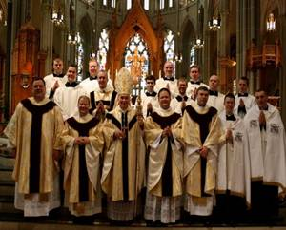   
*Bishop Foys with newly ordained priests  
for the Covington Diocese. Standing  
behind are future priests.*  
  
We Love Our Priests

    We are so pleased that Pope Benedict XVI declared this year the Year of the Priest! Many of you are aware of our dedication to praying for priests; we pray for the Pope, our local Bishop, Roger Foys, all Bishops in union with the Magisterium and all priests, deacons and seminarians every day. In addition to this we offer all of the priests on our list a “day of prayer,” where we offer our prayers and good works for a ***particular*** priest. We love our priests because of ***who*** they are in God’s family—our fathers—and because they are called to share in the Priesthood of Christ, Who “Himself builds up and sanctifies and rules His Body,” (CCC1563) and because only ***they*** can make Jesus Christ truly and substantially Present on earth in His Body, Blood, Soul and Divinity. No priest, no Eucharistic Lord.

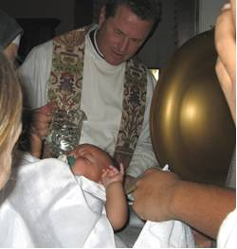  
*Msgr. J. Michael Due, VG*

  People have asked us how praying for priests is related to our pro-life charism. As sisters who are committed to pro-life issues we are dedicated to building up the family. Every good family needs healthy, well-adjusted mothers ***and fathers*** if there is any hope of raising healthy, well-adjusted children. We have always considered our Church as the “Family of God.” Even the Catechism of the Catholic Church states that, “The Church is nothing other than ‘the Family of God.’” (1655) So by praying for our priests we pray for our true spiritual fathers, and we assist in building up the family. That is what lies at the heart of being pro-life—the family. Our Lord has given us the family so that we could understand from Him Who ***Is*** Love (1John 4:8) how to love as God loves.

  In the perfection of love, the spouses are to be “subordinate to one another out of reverence for Christ.” (Eph 5:21) They love each other the way “Christ loved the Church and handed Himself over for her.” (Eph 5:25) True love gives without counting the cost, it is sacrificial. This is why we are so edified by priests who love the Lord with all of their hearts, souls, minds and strength, and who “spend themselves” for their Bride, the Church.

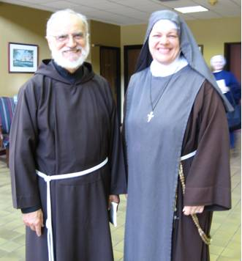 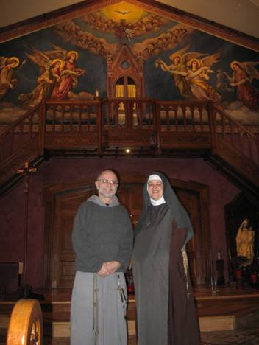  
*Fr. Raniero Cantalamessa, OFM Fr. Mariusz Koch, CFR*

     And love must be fruitful. “Marriage is based ... on their will to give themselves, each to the other, mutually and definitively, in order to live a covenant of faithful and fruitful love.” (CCC1662) An openness to life is one of the demands of the marital vows. I dare say, so too with the priesthood. Jesus Himself said, “By their fruits you will know them...every good tree bears good fruit.” (Mt 7:16,17) Our priests need our prayers to assist them in bearing good fruit for the Kingdom of God.

  So in praying for our beloved priests, we help in building up the “Family of the Church.” For we know, as Fr. Payton used to say, “The family that prays together, stays together.”

  Please join with the sisters in praying for our priests. To unite with Bishop Foys and the Covington diocese, you may consider praying the prayer below.  
  
Dear Lord,   
  
We pray that the Blessed Mother wrap her mantle around Your priests, and through her intercession strengthen them for their ministry.

We pray that Mary will guide Your priests to follow her own words, “Do whatever He tells you.”(Jn 2:5)

May Your priests have the heart of St. Joseph, Mary’s most chaste spouse.

May the Blessed Mother’s own pierced heart inspire them to embrace all who suffer at the foot of the Cross.

May Your priests be holy, filled with the fire of Your Love seeking nothing but Your greater glory and the salvation of souls.

 St. John Vianney, patron of priests,

Pray for Us

Amen.

Stories From the Mission   
  
    The Lord is continuing to multiply “the loaves and fish” at the Mission. We realized on a recent Monday, that we had nothing to offer the families; no diapers and no food. So we decided to go to one of the local stores to purchase some. As we were preparing to leave, we received a phone call asking if we needed food. Excitedly we said, “Absolutely!” Before opening, we were given enough food to feed about 400 families. Well, at the end of the day we counted how many people came to us for help, and there were 845—and the food lasted all day long, with leftovers for the next day. The following day, the food didn’t run out until 4pm, when we had served 285 families. How generous God is to His beloved poor!  
  
  
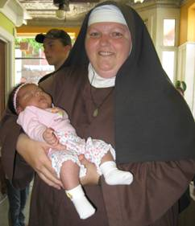            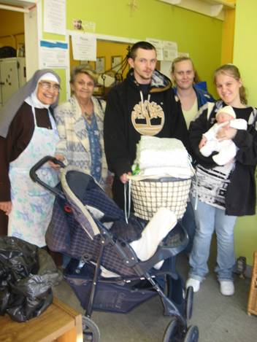

  A lady we had not seen before came to us asking for food. She then shared with us her gratitude for helping her son who had been laid off from his job and who came to us for something to eat. She explained that he couldn’t find work and this caused him to fall in to a deep depression and was tempted to “end it all.” She went on to tell us how when he came to us we gave him food and were nice to him, then coming back the next day we again gave him food and were nice to him. The next day he came to us again, and once more we gave him food and were nice to him. She told us that by the non-judgmental and friendly way we treated him at the Rose Garden, it gave him the hope he needed to get back up on his feet, and that he had now found a new job and was doing well again. All praise to our Lord Jesus Christ!

A young Mom of two children in diapers asked for a pregnancy test. Upon testing positive, she began to quietly cry. Sister asked her what was wrong and she responded that she couldn’t handle another one. Between her two, her sister’s children and the cramped quarters they lived in, it was just too much for her. Sister spoke to her gently and she chose to put the child up for adoption.

   Meanwhile, there was another woman who was waiting for help who we knew was working to adopt her family member’s child. So we asked if she would sit and talk with this young Mom about the joy she experienced in preparing to welcome this baby in to her family. She shared with her how when first considering the aspect of brining another child in to her home, she also was unsure if she could handle it, but the need for this child to get out of an extremely negative situation led her to choose to adopt. Now she is overjoyed at the prospect of finalizing the adoption.

   A few weeks later, the pregnant Mom made a point of telling us that she had decided to keep this child and was now actually looking forward to the birth. In her eighth month of pregnancy, while we were getting together a New Baby Welcome Basket for her, she shared with us that she was carrying twins! She also shared that she was ready to welcome ***both*** children in to her family. What a beautiful witness to Life.

    We are so grateful to the Lord for the way you love Him through the prayers, assistance and support you give to us. You and your intentions are remembered each day at the sisters’ Morning and Evening Prayers. May our Lord Jesus Christ shower you with an abundance of graces and blessings.

Mother Seraphina

